**E-Commerce Shipping Dataset**

Dataset : <https://www.kaggle.com/datasets/prachi13/customer-analytics>

**Analytical Conclusion**

**Based on the provided dataset, the analysis covers several key aspects related to the shipment and delivery performance of a logistics company. Here are the primary findings:**

1. **Warehouse and Shipment Mode:**
   * **The data includes shipments from multiple warehouse blocks (A, B, C, D, F) and different modes of shipment (Flight, Ship, Road).**
   * **The distribution and performance of these blocks and shipment modes could reveal efficiency patterns and potential areas for improvement.**
2. **Customer Service and Ratings:**
   * **The dataset includes variables for the number of customer care calls and customer ratings.**
   * **Higher customer care calls might indicate issues in the delivery process, while customer ratings provide insight into overall satisfaction.**
3. **Product and Purchases:**
   * **Attributes like the cost of the product, prior purchases, and product importance (low, medium, high) give a comprehensive view of the product dynamics and customer purchase behavior.**
   * **Understanding these factors can help tailor services to different product categories and purchase frequencies.**

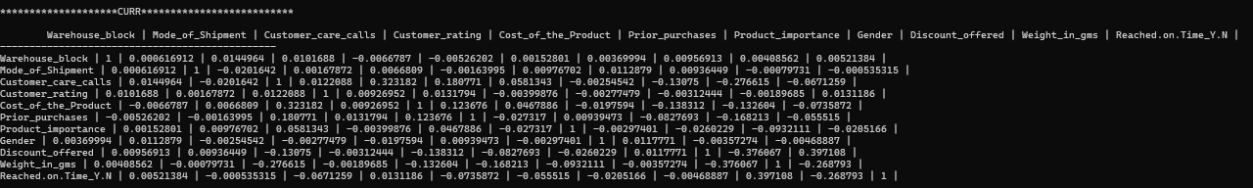

Note :

Conclusions from Correlation matrix :-

Discount Offered have high positive correlation with Reached on Time or Not of 40%.

Weights in gram have negative correlation with Reached on Time or Not -27%.

Discount Offered and weights in grams have negative correlation -38%.

Customer care calls and weights in grams havenegative correlation -28%.

Customer care calls and cost of the product have positive correlation of 32%.

Prior Purchases and Customer care calls have slightly positive correlation

SO Some,

Some Visualization to Describe the columns :

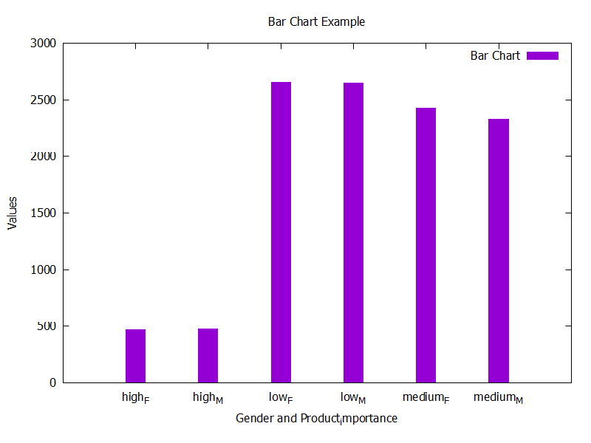

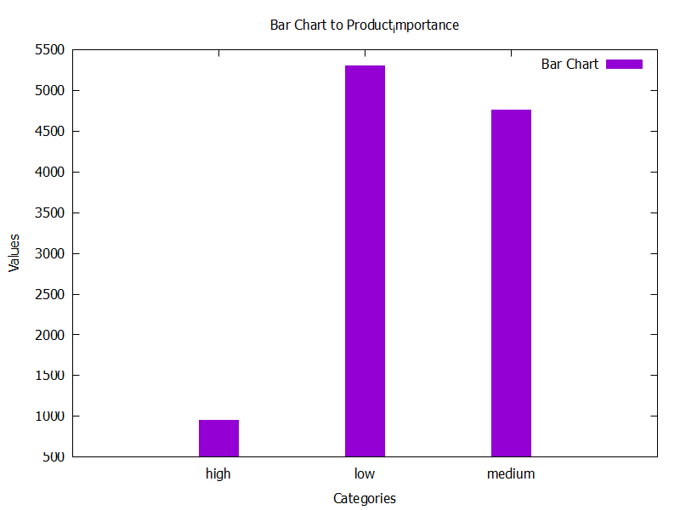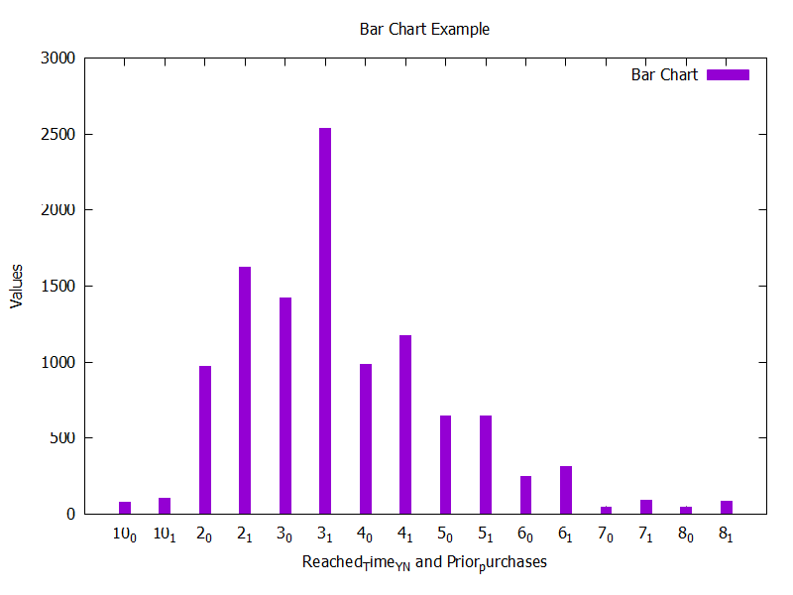

Overview to Relation between Prior purchases Column and Reached on time Column

Overview of Product importance Column

Overview to Relation between Gender Column and Product importance Column

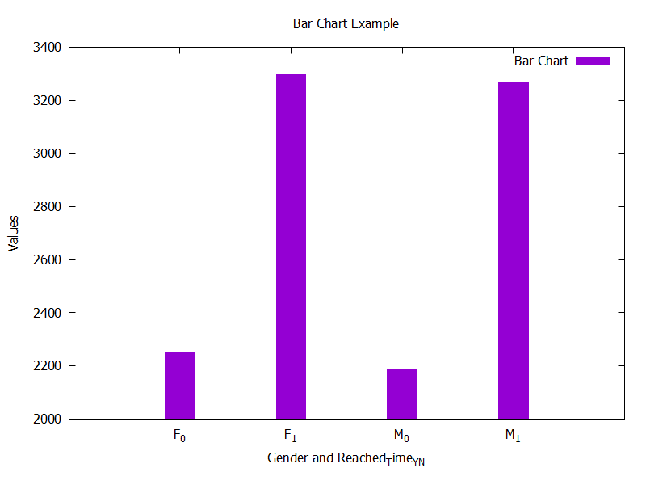

Overview to Relation between Gender Column and Reached on time Column

Overview of Warehouse block Column

Overview to Relation between Reached on timeColumn and Product importance Column